

**Executive Summary: CoachesPick SaaS website**

CoachesPick is a SaaS-based sports management system designed to streamline operations for youth sports organizations. It caters to users under the age of 20 and serves multiple stakeholders, including League Owners, Coaches, Players, Referees, Parents, Staff, Volunteers, and Photographers.

The platform supports end-to-end functionality for managing leagues, clubs, seasons, programs, schedules, registrations, teams, reports, finance, and media assets.

### **Architecture**

* **Backend Framework:** NestJS (microservice architecture)
* **Frontend Framework:** Next.JS
* **Infrastructure:** Fully serverless using AWS Lambda
* **API Gateway:** REST APIs exposed via AWS API Gateway per service
* **Database:** Amazon DynamoDB (separate tables per entity)
* **Authentication:** AWS Cognito (user pools for secure signup/login)
* **Interservice Communication:** Primarily using REST API call
* **Storage:** Amazon S3 (for media uploads, reports, and templates)
* **Email:** Amazon SES (for automated emails with dynamic templates)
* **Docs:** Swagger OpenAPI integrated and hosted per Lambda endpoint
* **Agile:** Jira Atlassian

### **Microservices and Their Responsibilities**

#### **Auth Service**

* Manages sign-up, sign-in, password management, role assignment, and user management.
* User roles include: LeagueOwner, Coach, HeadCoach, AssistantCoach, Player, Parent, Volunteer, Referee, Photographer.
* Stores user attributes like userSub, email, name, role, phone, location.

#### **Finance Service**

* Manages payments, discounts, fees, refund workflows, subscription, and coupons.
* Generates invoices, tracks payment status, and handles registrations of league owners through Stripe connect.
* Integrates with 3rd party payment gateways (planned).

#### **League Management Service**

* Manages creation and configuration of leagues, clubs, national affiliations, and seasons.
* Handles program registration settings.
* Tracks affiliations, team assignments, and player categories.

#### **Profile Service**

* Manages detailed user profiles with extended fields (e.g., contact, medical info, jersey size, etc.), ToDo task management and chat image management.
* Bulk Profiles are also added using CSV files.
* Supports profile updates, retrieval, and report fetch requests.

#### 

#### 

#### 

#### **Schedule Management Service**

* Handles program management, Team management, game, practice, event scheduling, standings, location, matches, participation, questions (during program creation).
* Integrates with blackout dates, time slots, and location availability.
* Notification triggers for changes or cancellations.

#### **Report Service**

* Generates dynamic reports like enrollment summaries, rosters, volunteer, volunteer verification, team detail, returning participant, inactive participant, division, profile data exports, etc.
* Consumes data from other services (e.g., Profile, Program) via RestApi call.
* Supports on-demand reporting.

#### **Shared Service**

* Manages organization, chat groups, group messages, email, sms, default themes and group Email.
* Shared across all microservices for consistency.

#### **Website Service**

* Public site configuration per league (e.g., theme, programs, contact).
* Displays upcoming events, registration details, and league-specific pages.
* Supports dynamic CMS-like editing by League Owners.
* Manages Public website content, banner, rotator, field status, news, and highlights.

#### **Website Home Service**

* Handles sponsors, featured sponsors, announcement data banner, interest list, site link, and schedule info.
* Public website home listings.

### **Role and Rights Management**

* Implemented as a centralized configuration stored in DynamoDB.
* Each role has specific rights (CRUD operations on entities) that govern platform behavior.
* Roles and permissions can be dynamically extended or revoked.

### **Tenant Isolation**

* Multi-tenant architecture supported using **separate tables for each league owner in a single AWS account for cost management**.
* Each tenant has isolated DynamoDB tables.

### **CI/CD & Deployment**

* Codebase managed via GitLab with CI/CD pipelines.
* Deployments are triggered per environment using serverless commands.

**Lambda Deployment**

Commands: To set AWS Access Keys before Lambda deployment

-> aws configure

- Enter AWS Access Key ID

- Enter AWS Secret Access Key

- Enter Default region name (ex - us-east-1)

-> serverless deploy

Note: Make sure serverless.yaml is configured in your root directory

Command to Test the Lambda function locally before it get deployed

-> serverless invoke local --function createLeague --path test-event.json

-> serverless deploy function --function createLeague

-> serverless deploy --config serverless-new.yml

-> serverless logs -f createLeague // check log by lambda fun name

-> aws lambda get-function --function-name <function-name> --query 'Code.Location' --output text

**Login Page:**

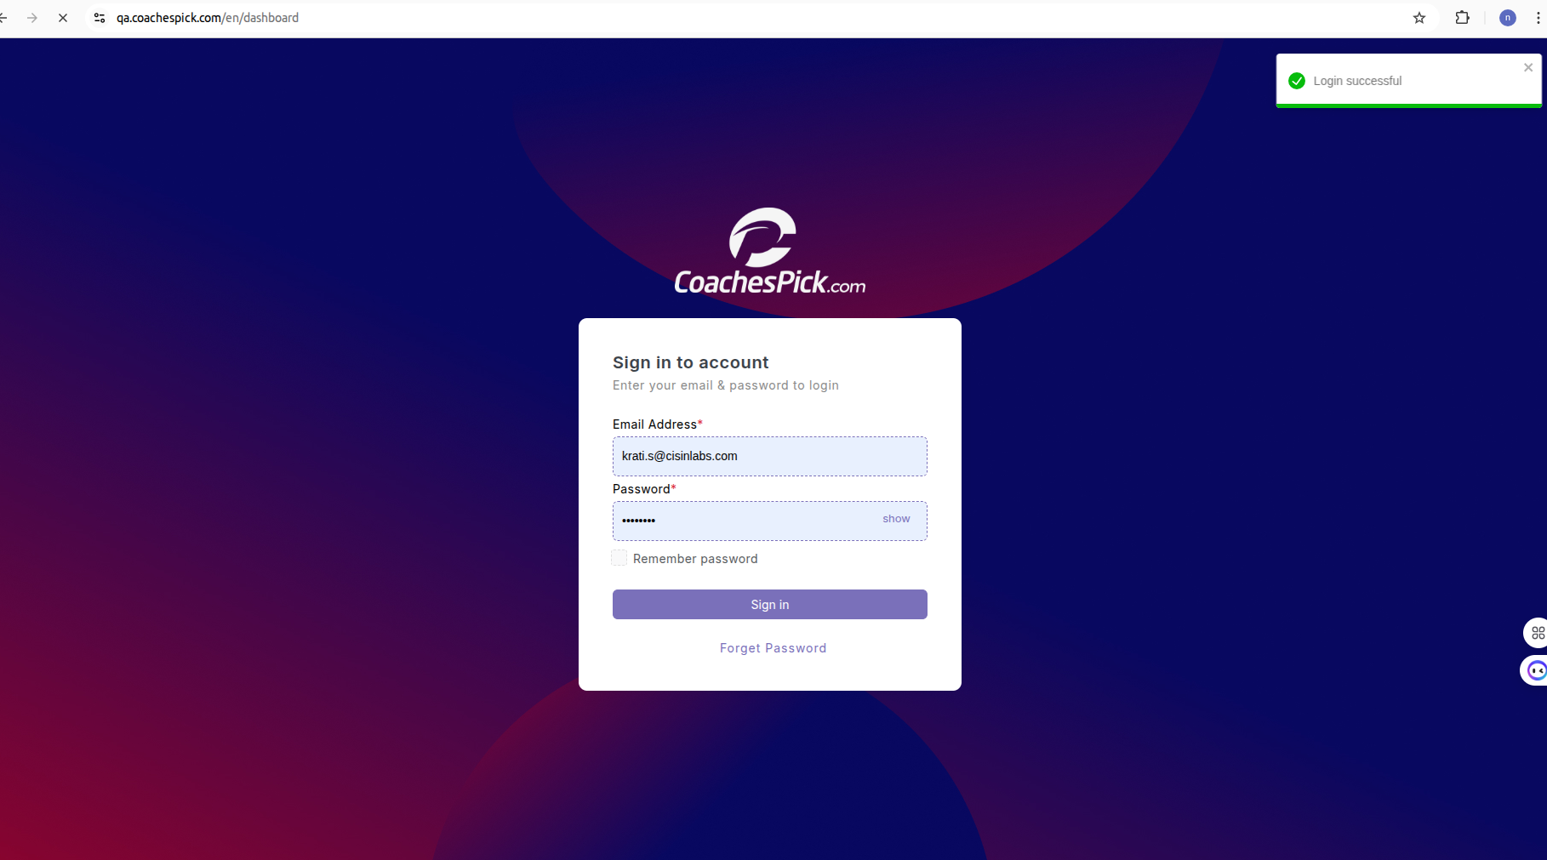

**Overview**

From this **Login Page**, both **Admin** and **League Owners** can securely log in using their credentials. Upon successful authentication:

* **Admins** are redirected to the **Admin Dashboard**, where they can manage global settings, oversee all leagues, review system-wide reports, and perform administrative actions across the platform.
* **League Owners** are redirected to their **League Dashboard**, which provides access to all league-specific functionalities, including:
* Event and Program Management
* Player and Team Management
* Volunteer and Coach Assignments
* Scheduling and Blackout Dates
* Messaging and Notifications
* Financial Reports and Registration Tracking
* Public Website Configuration

The login process is secured via **AWS Cognito**, ensuring encrypted credentials, token-based authentication, and secure session management. Role-based access control ensures that users can only view and manage features permitted for their specific roles.

**League Owner Dashboard:**

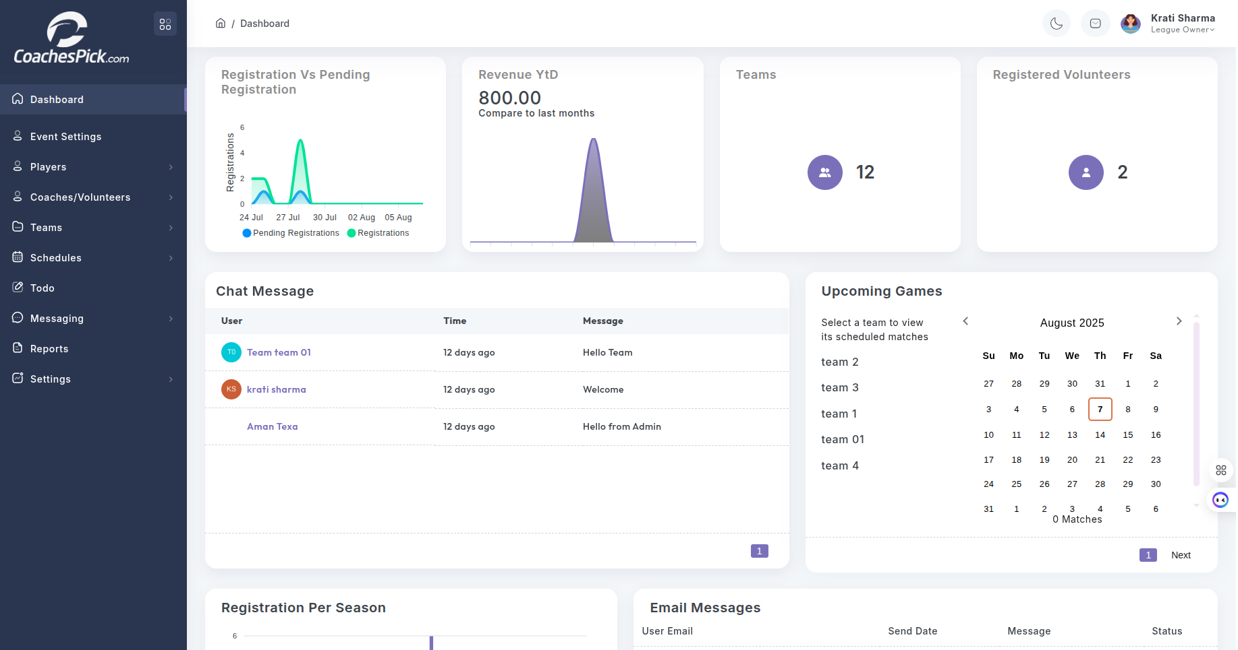

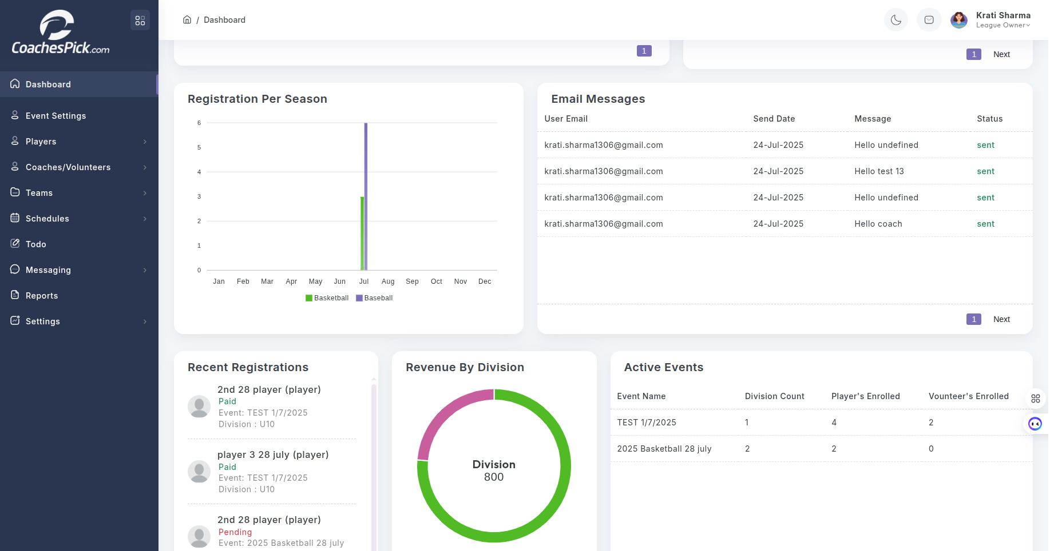

**Overview**

Dashboard displays the matrix data of activities performed in his/her dashboard. League owners can have an overview of how many registrations are there, revenue generated, number of teams, registered volunteers, chat messages, upcoming games, registration per season, email messages, active events, revenue by divisions, and recent registrations done.

**Event Settings**

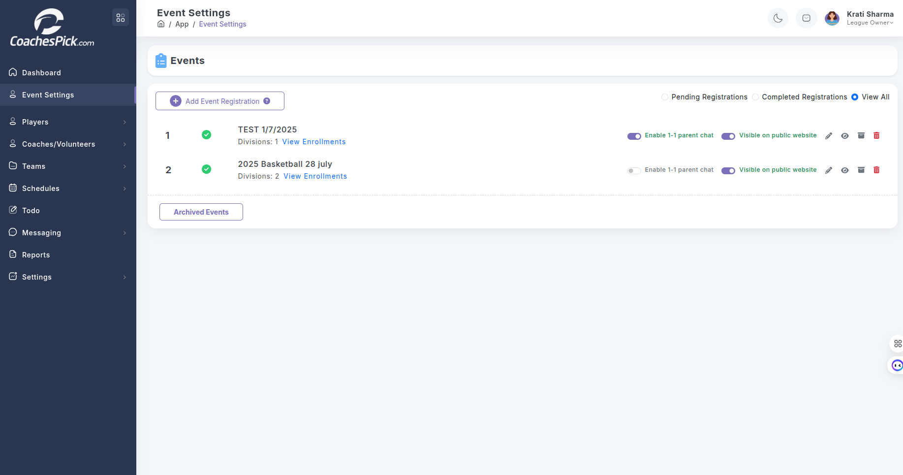

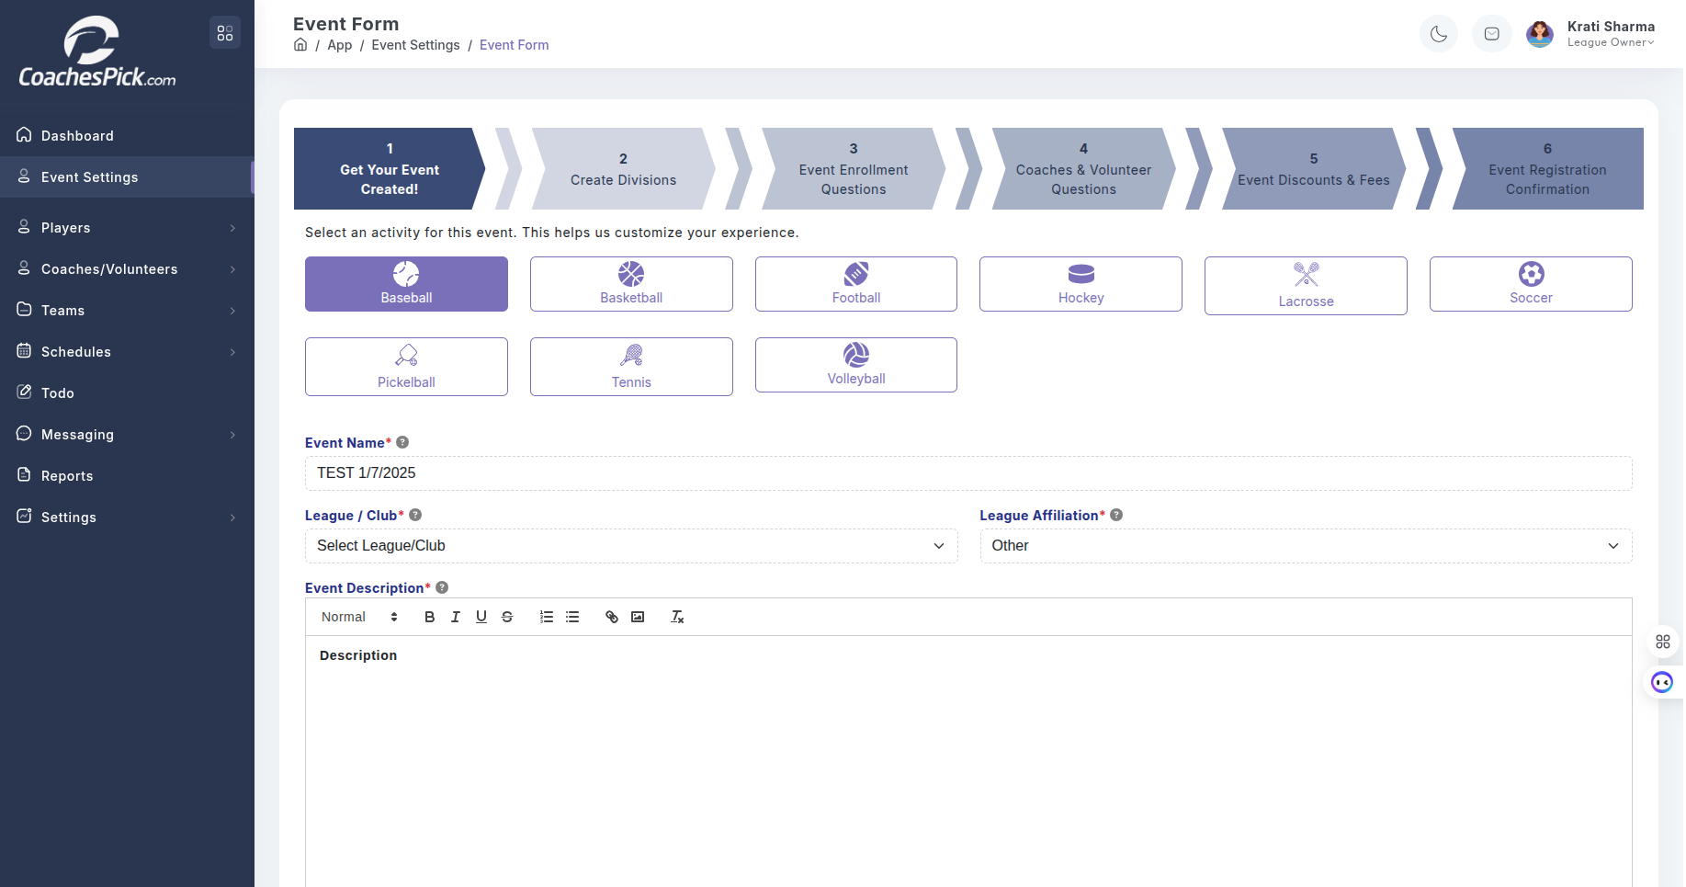**Overview**

The Event Form in CoachesPick is a step-by-step interface designed for League Owners to create and configure sports events efficiently. It guides the user through a structured 6-step process, ensuring all key event parameters are captured in a logical flow:

### **Purpose and Usability:**

* The form is tailored for youth sports organizations to manage structured programs.
* The user interface is clean, guided, and intuitive, reducing complexity for non-technical users.
* The left-hand sidebar provides quick access to modules like Players, Teams, Schedules, Messaging, and Reports - ensuring efficient navigation throughout the platform.
* The form ensures data completeness and validation before allowing progression to the next step.

**Players**

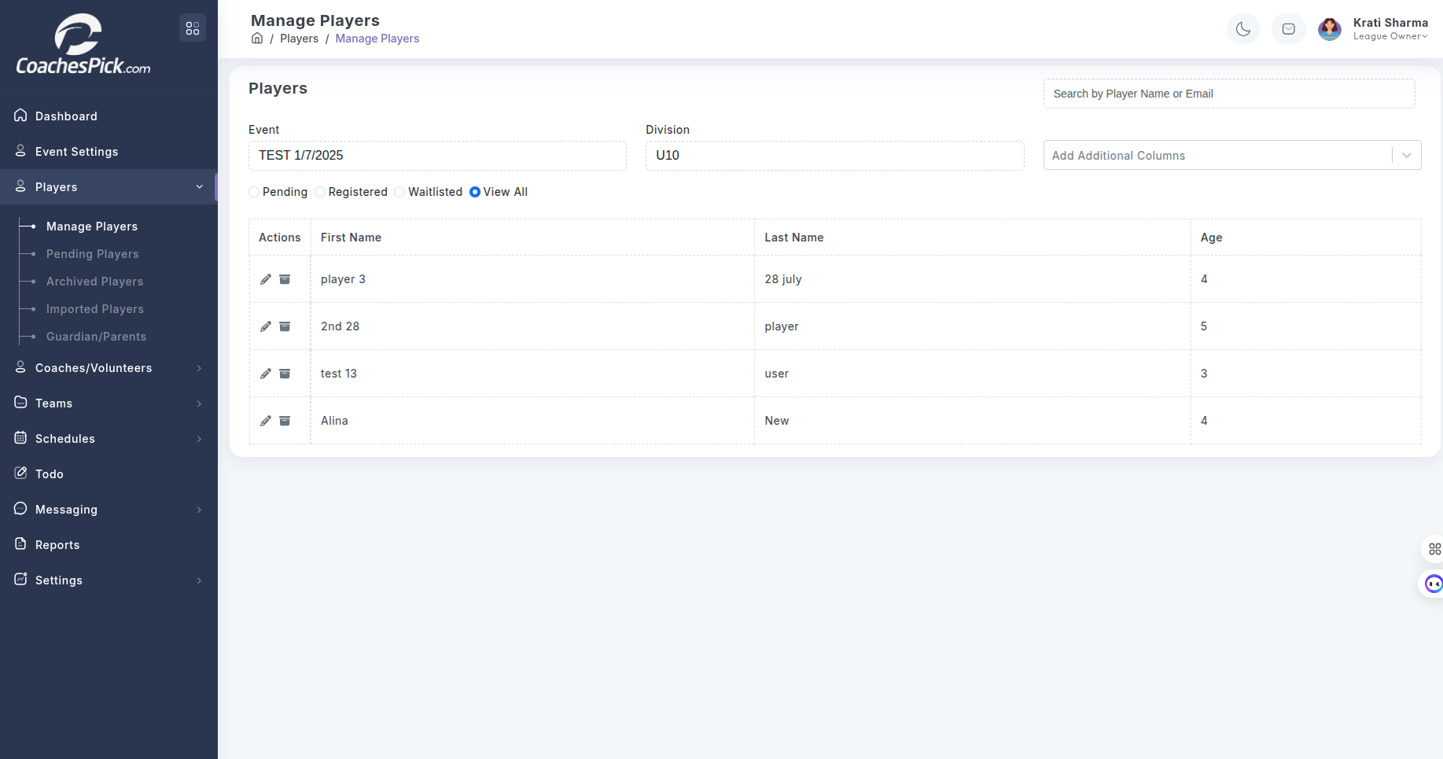

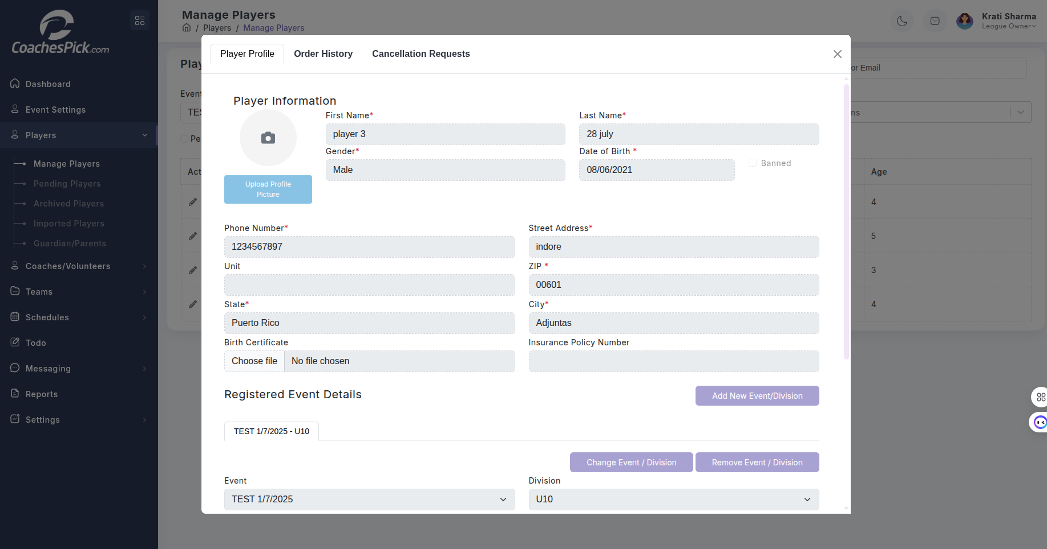

**Overview**

From Manage players the league owner can add new players, edit existing players - change in division or program or event settings for which he was registered previously, check order history of that player and any cancellation request generated by his parents or guardians.

**Coaches**

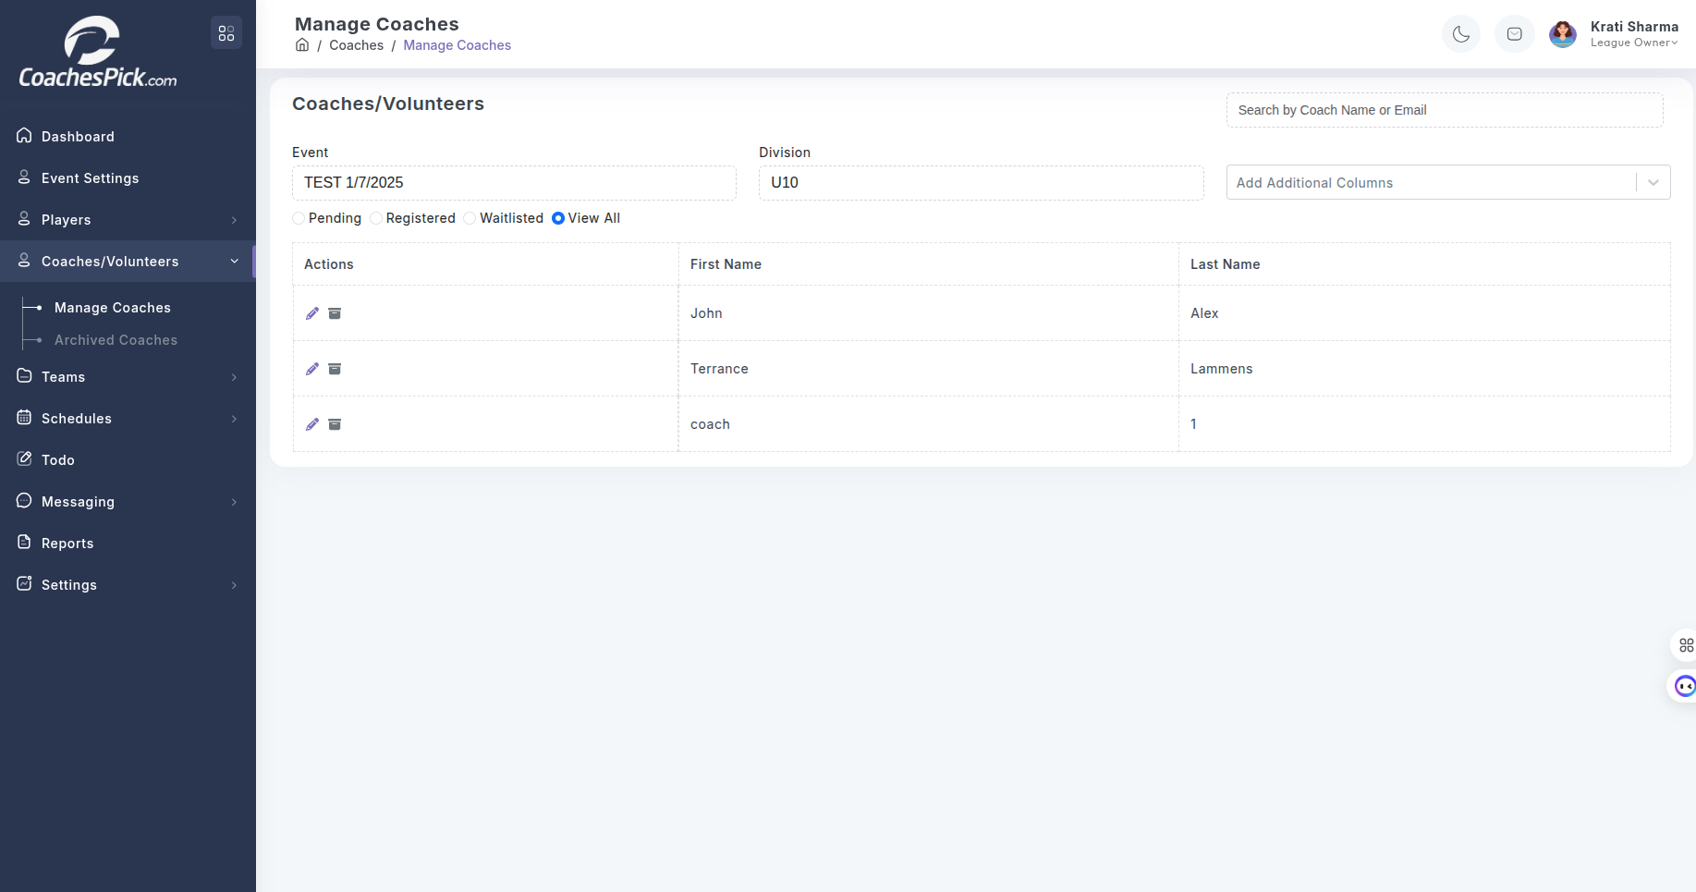

**Overview**

Same as Manage Players. Archives feature is also there.

**Schedules**

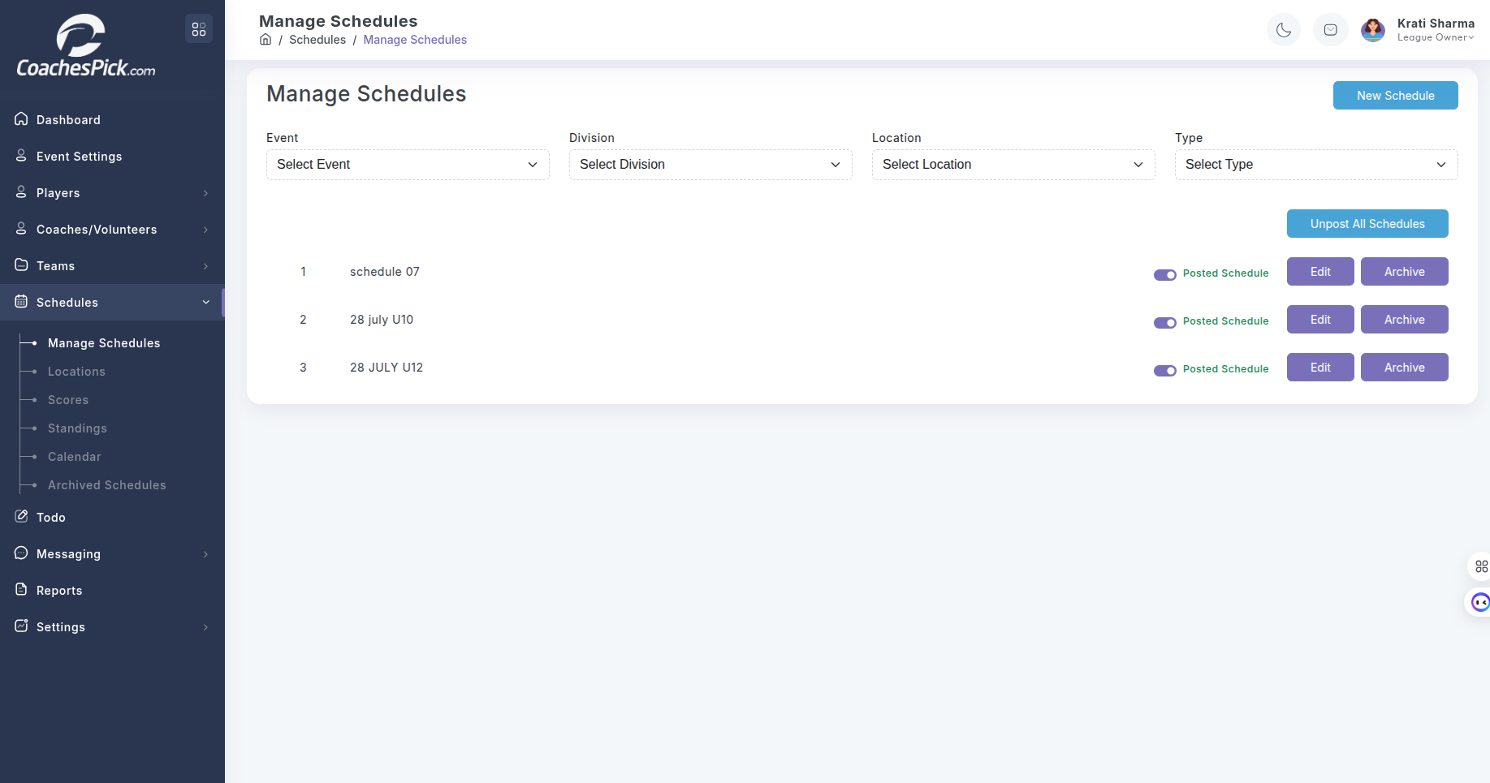

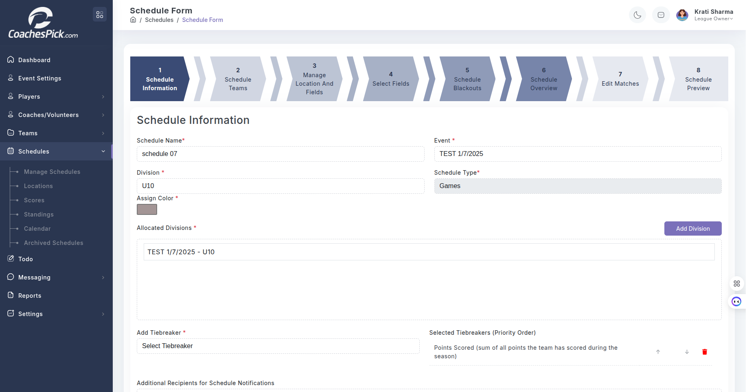

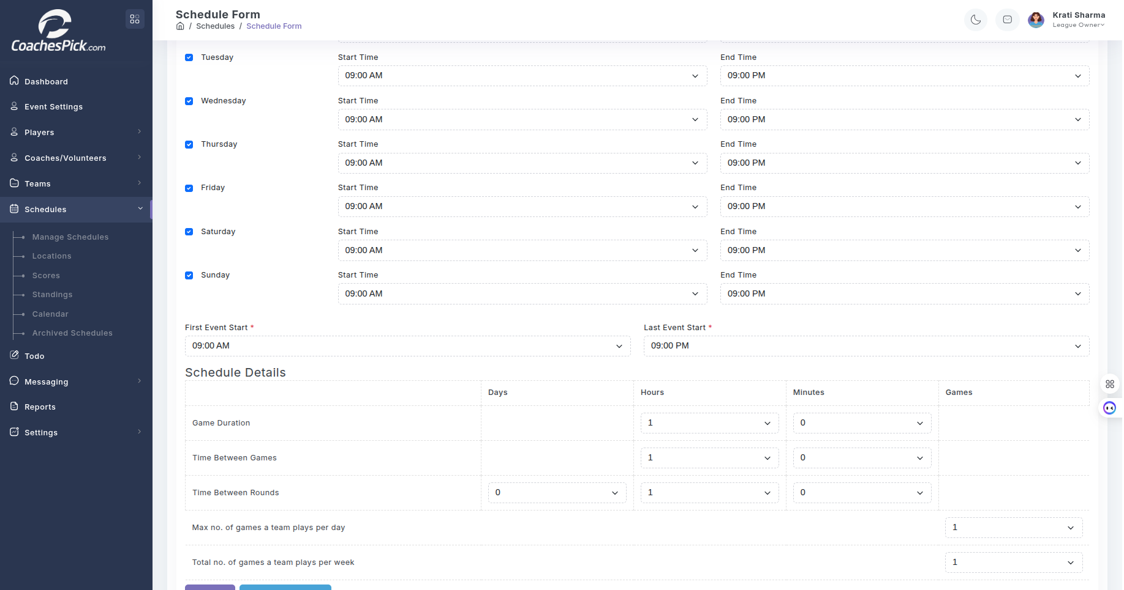

**Overview**

The **Schedules** module in CoachesPick allows League Owners, Coaches, and Staff to efficiently manage all scheduling-related aspects of sports programs. It is designed to accommodate complex scheduling needs for youth leagues, including practices, games, events, and more.

#### **1. Program-Based Scheduling**

* Schedules are created within the context of a **Program**, ensuring relevance to teams, divisions, and participants.
* Each event (game, practice, or custom) is linked to specific teams and locations.

#### **2. Game & Practice Management**

* Users can create and edit:
* **Games** with home/away teams, scores, and result tracking
* **Practices** for individual or multiple teams
* Supports recurring sessions and multi-field assignments.

#### **3. Event Scheduling**

* Custom events like tryouts, parent meetings, and league-wide events can be scheduled.
* Option to notify participants or restrict visibility based on roles.

#### **4. Blackout Dates Integration**

* Automatically disables or blocks scheduling on **blackout dates** (e.g., holidays, field maintenance days).
* Prevents accidental conflicts with pre-defined unavailable dates or times.

#### **5. Location & Time Slot Allocation**

* Assign events to specific **fields**, **court**, or **venues**.
* Supports availability checking to avoid double-booking of locations or time slots.

#### **6. Participation Tracking**

* Each scheduled activity records participation:
* Players’ attendance
* Coaches’ presence
* Referee and Volunteer assignments (if applicable)

#### 

#### **7. Standings & Results Integration**

* Game results flow into **standings** and team performance tracking.
* Admins or authorized roles can input scores and match outcomes.

#### **8. Notifications & Alerts**

* Automatic email/SMS notifications for schedule changes or cancellations.
* Custom reminders can be configured based on event type or timing.

**Reports:**

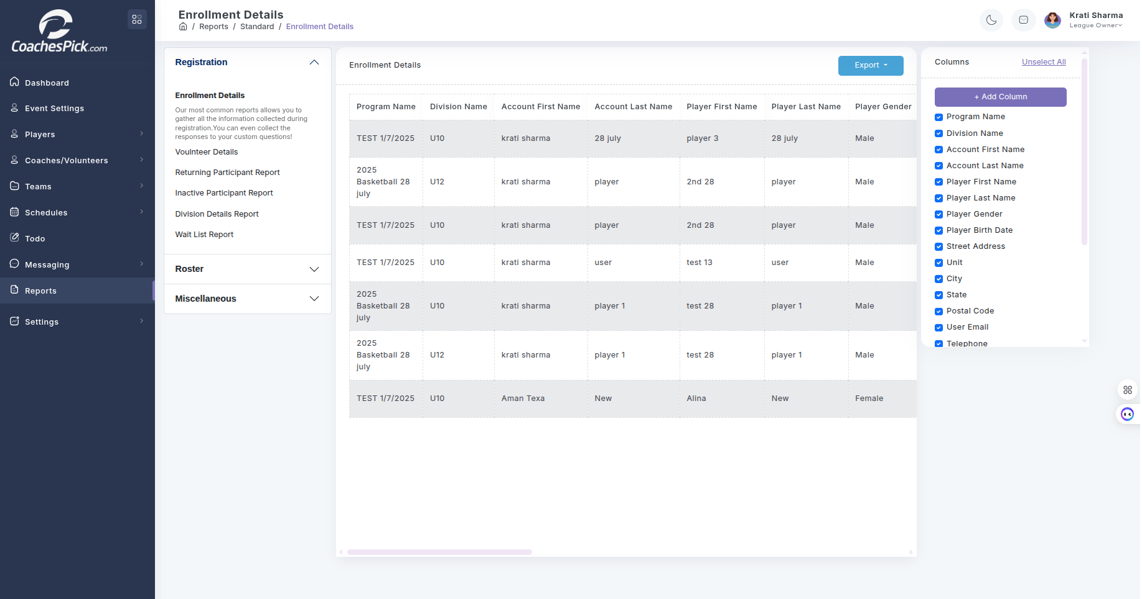

**Overview**

Reports with Easily **customize visible columns** using the dynamic column selection panel on the right. Users can show/hide fields like: Player Birth Date, Address, Email, Telephone, and more.  
Could Export data using the **Export** button for offline processing, printing, or reporting to governing bodies.

#### **Registration Reports**

* **Enrollment Details** – Full view of registration entries.
* **Volunteer Details** – Tracks volunteer roles and availability.
* **Returning Participant Report** – Identifies returning players.
* **Inactive Participant Report** – Flags users who haven't registered recently.
* **Division Details Report** – Summarizes division-level data.
* **Wait List Report** – Lists participants on waitlists.

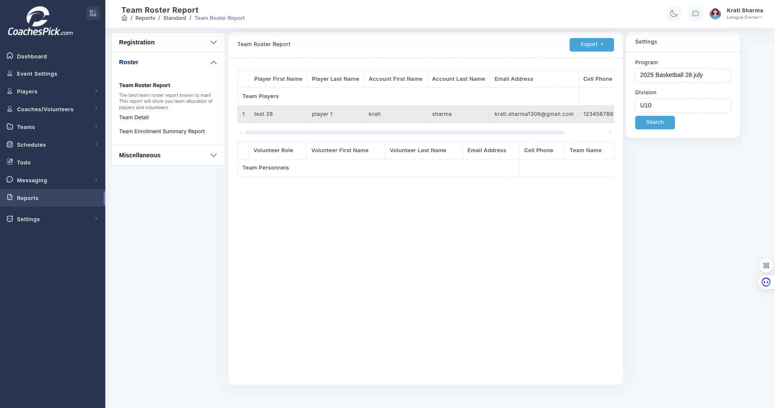

#### **Roster**

Focused on team-level organization, this group includes:

* **Team Roster Report** – Displays team-wise allocation of players and volunteers with full contact information. The right panel allows filtering by **Program** and **Division** for targeted results. The report is exportable for offline use.
* **Team Detail** – Offers more granular data about teams, including performance and stats (if available).
* **Team Enrollment Summary Report** – Summarizes enrollment numbers per team or division.

**Settings:**

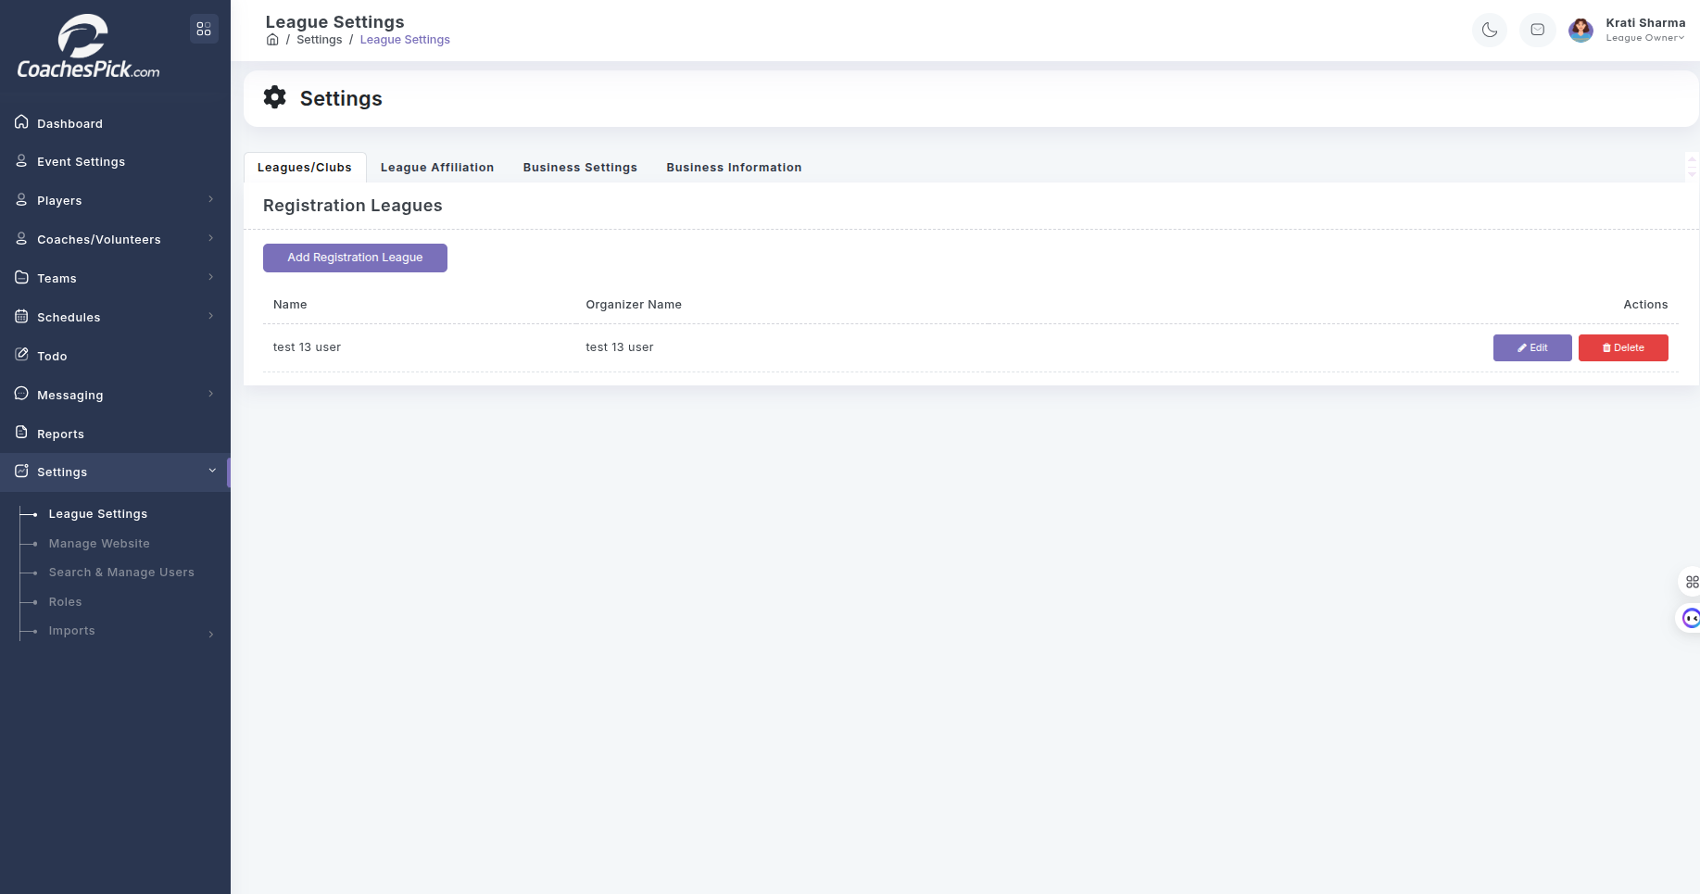

**Overview**

In the **League Settings**:

* League Owners can manage **Leagues/Clubs**, **Affiliations**, **Business Settings**, and **Business Information**.
* Leagues are listed with organizer details and can be **edited** or **deleted**.
* “Add Registration League” allows users to create new league entries for registration purposes.

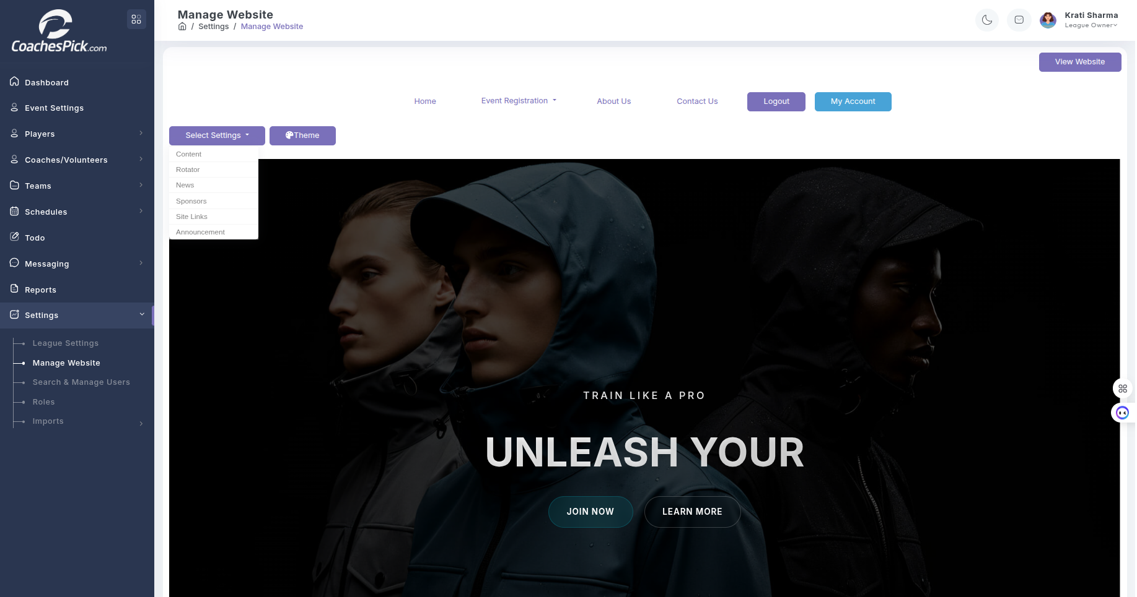

In the **Website Manage Settings**:

The Manage Website feature provides a built-in CMS-like interface for League Owners to control the public-facing site:

* Customize Themes, Content, News, Rotators, Sponsors, and Site Links.
* View live updates using the View Website button.
* Modify homepage content like banners, announcements, and event registration options.
* This interface empowers non-technical users to maintain their own league's website without needing external web developers.

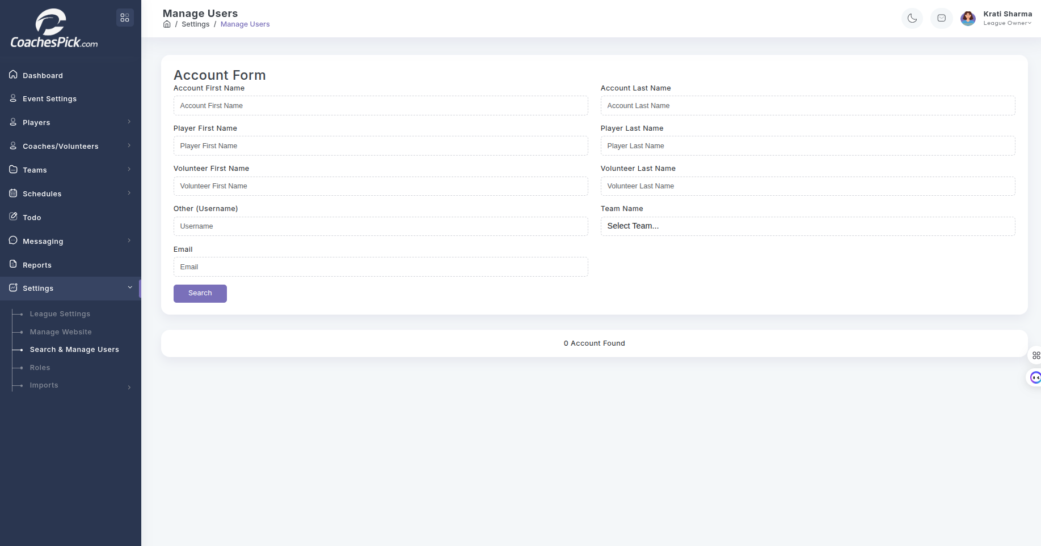

#### In the **Manage Users:**

* Search Panel allows filtering by:
  + Account Name, Player Name, Volunteer Name, Username, Email, and Team Name.
* Useful for league administrators to quickly locate and manage user accounts.
* Displays real-time results in a table format below the search fields.

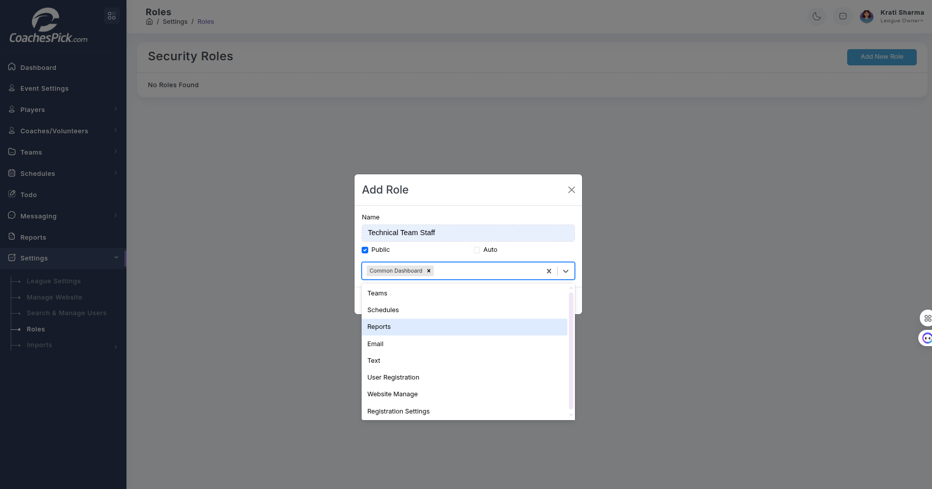

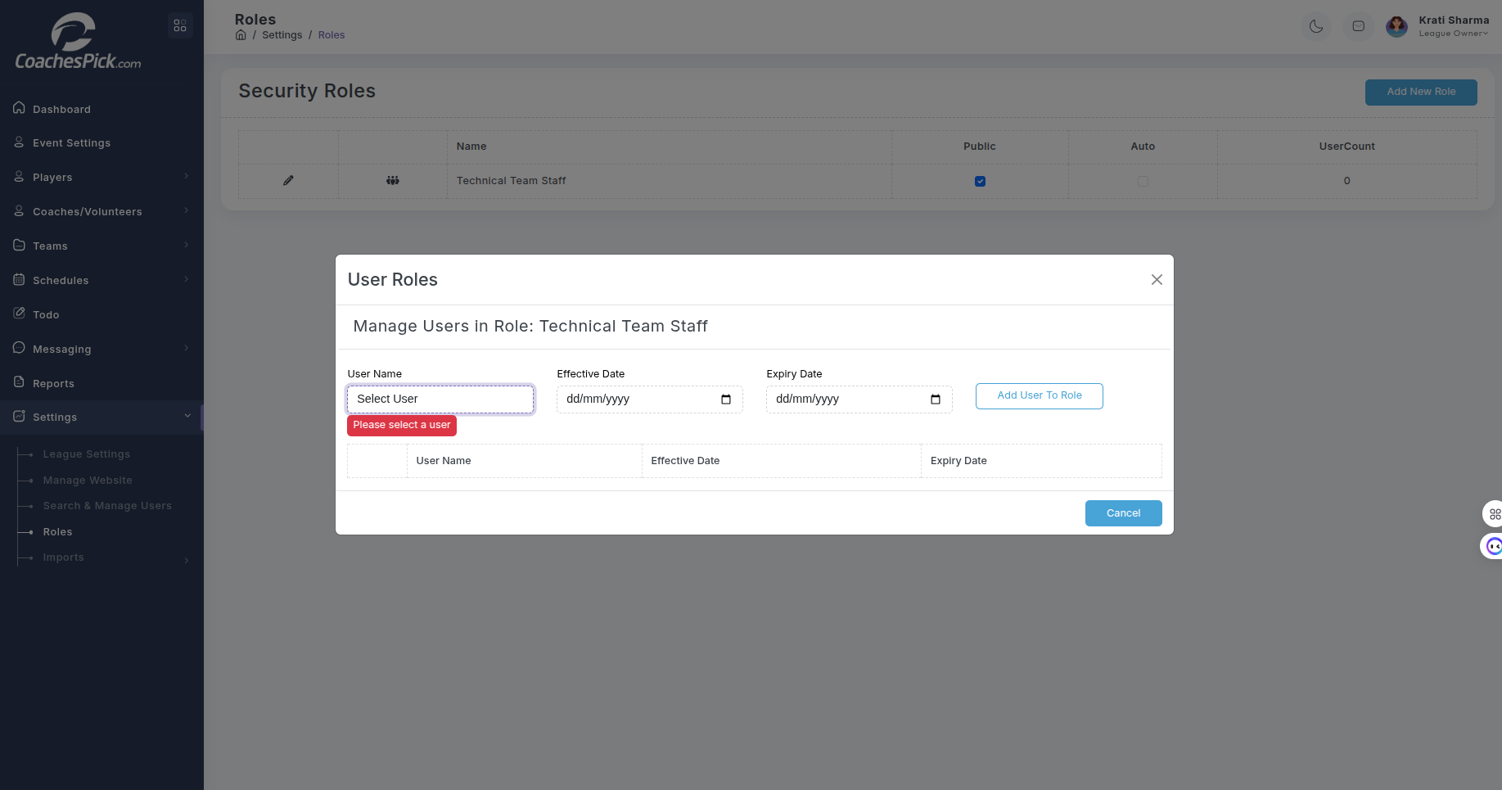

#### In the **Roles:**

**Security Roles Management**:

* Admins can create and manage user roles (e.g., "Technical Team Staff").
* Roles can be marked as Public or Auto-assigned.

**Assigning Users to Roles**:

* Selection of User
* Set Effective and Expiry Dates
* Assign via the “Add User to Role” action
* A table displays current role assignments with date ranges.



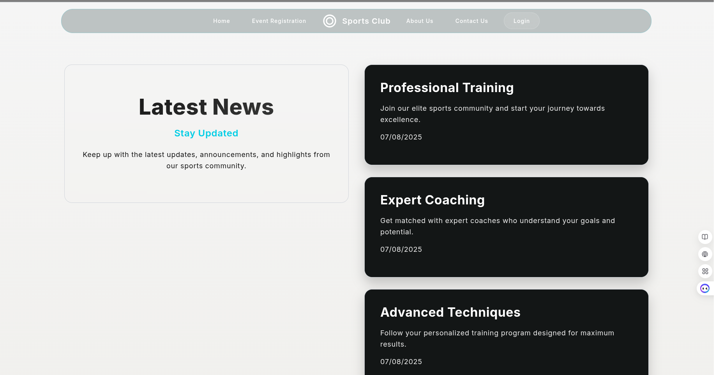

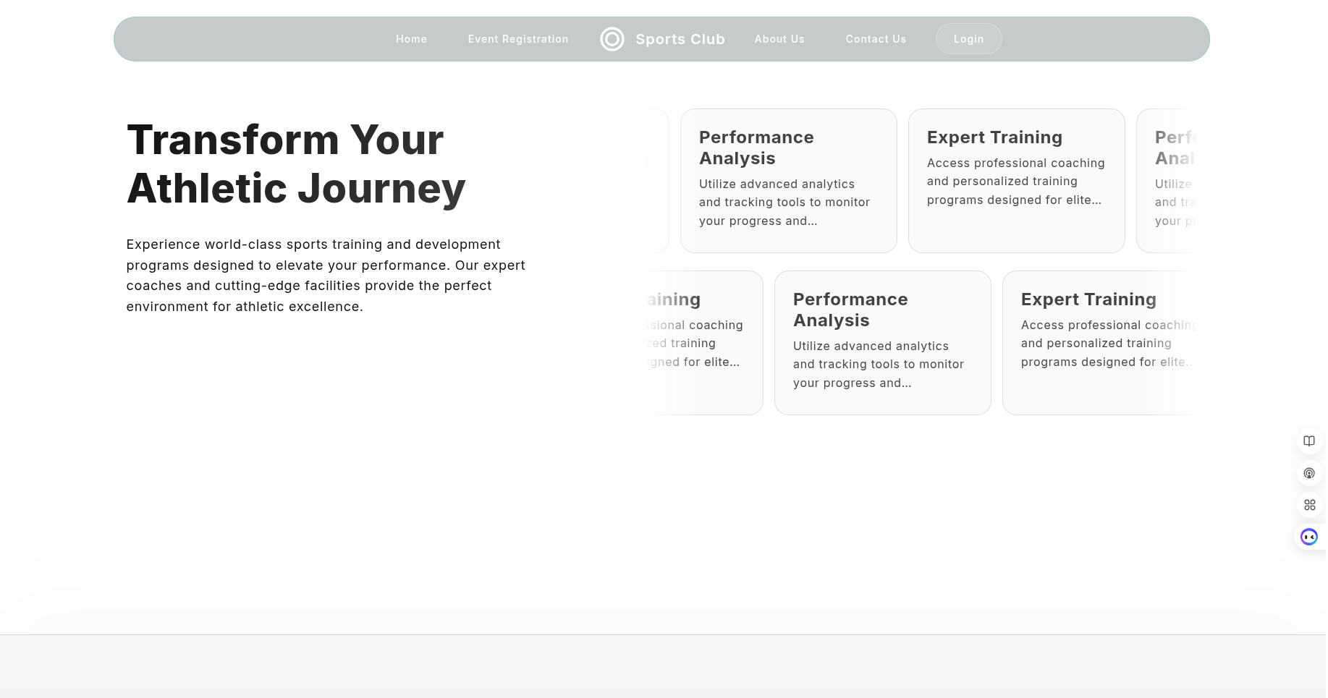

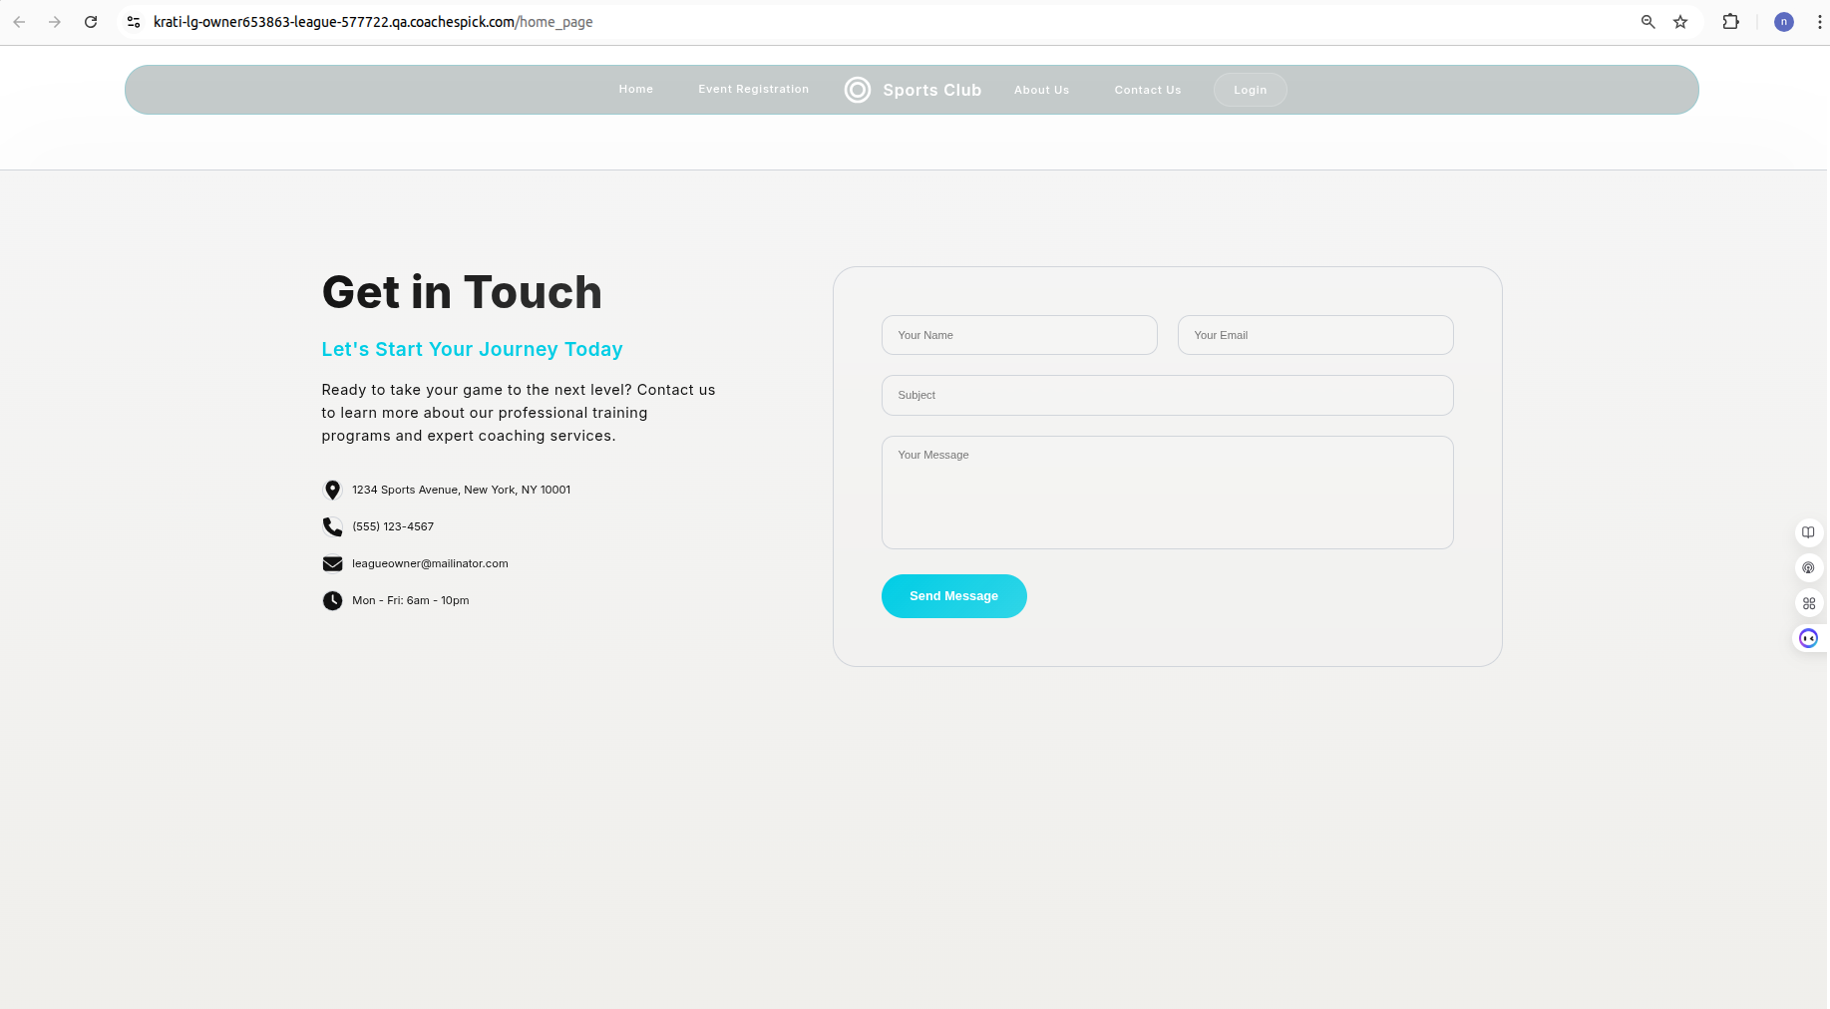

Above Screenshots are of Public Websites - which are managed by league owners per League.

**Login Page - Public Website**

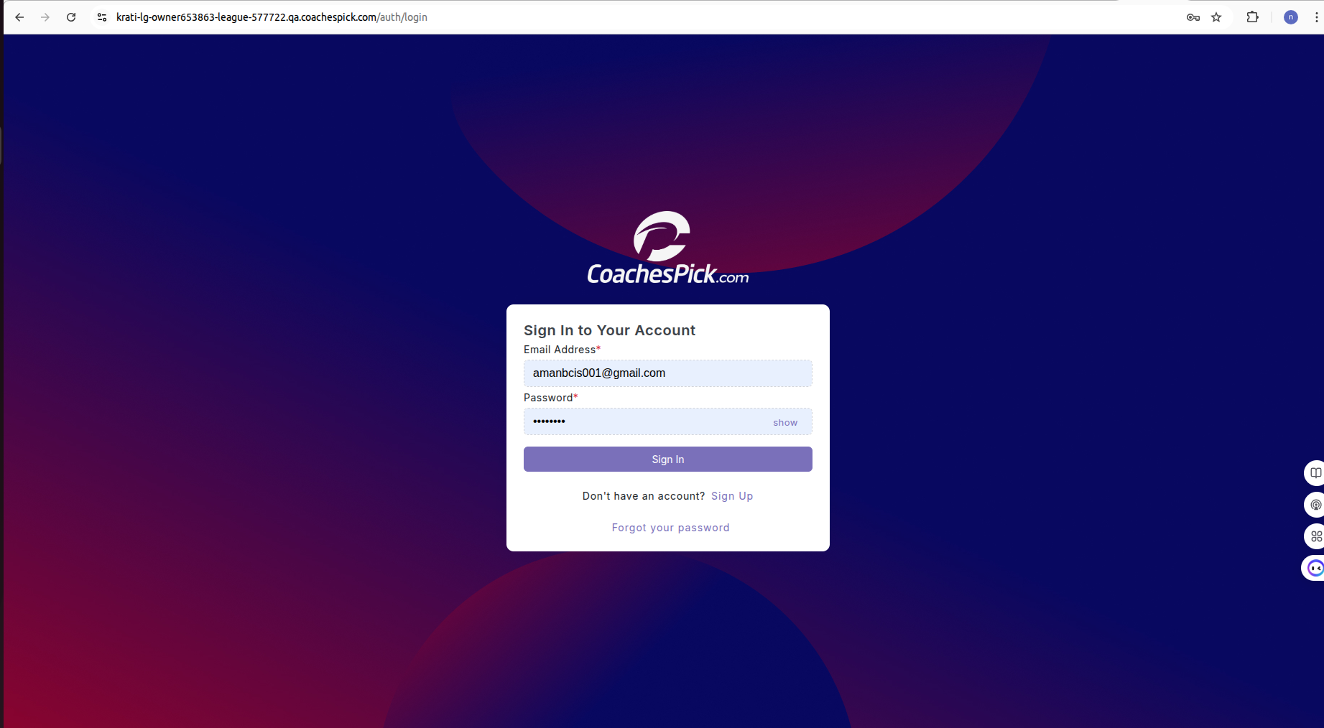

**Overview**

The platform begins with a secure login page where Admins and League Owners can sign in using their email and password. The login form includes options to:

* Show/hide password
* Sign up for a new account
* Recover a forgotten password

The login screen is professionally styled with a modern dark theme and branding.

**Dashboard - Public Website Login**

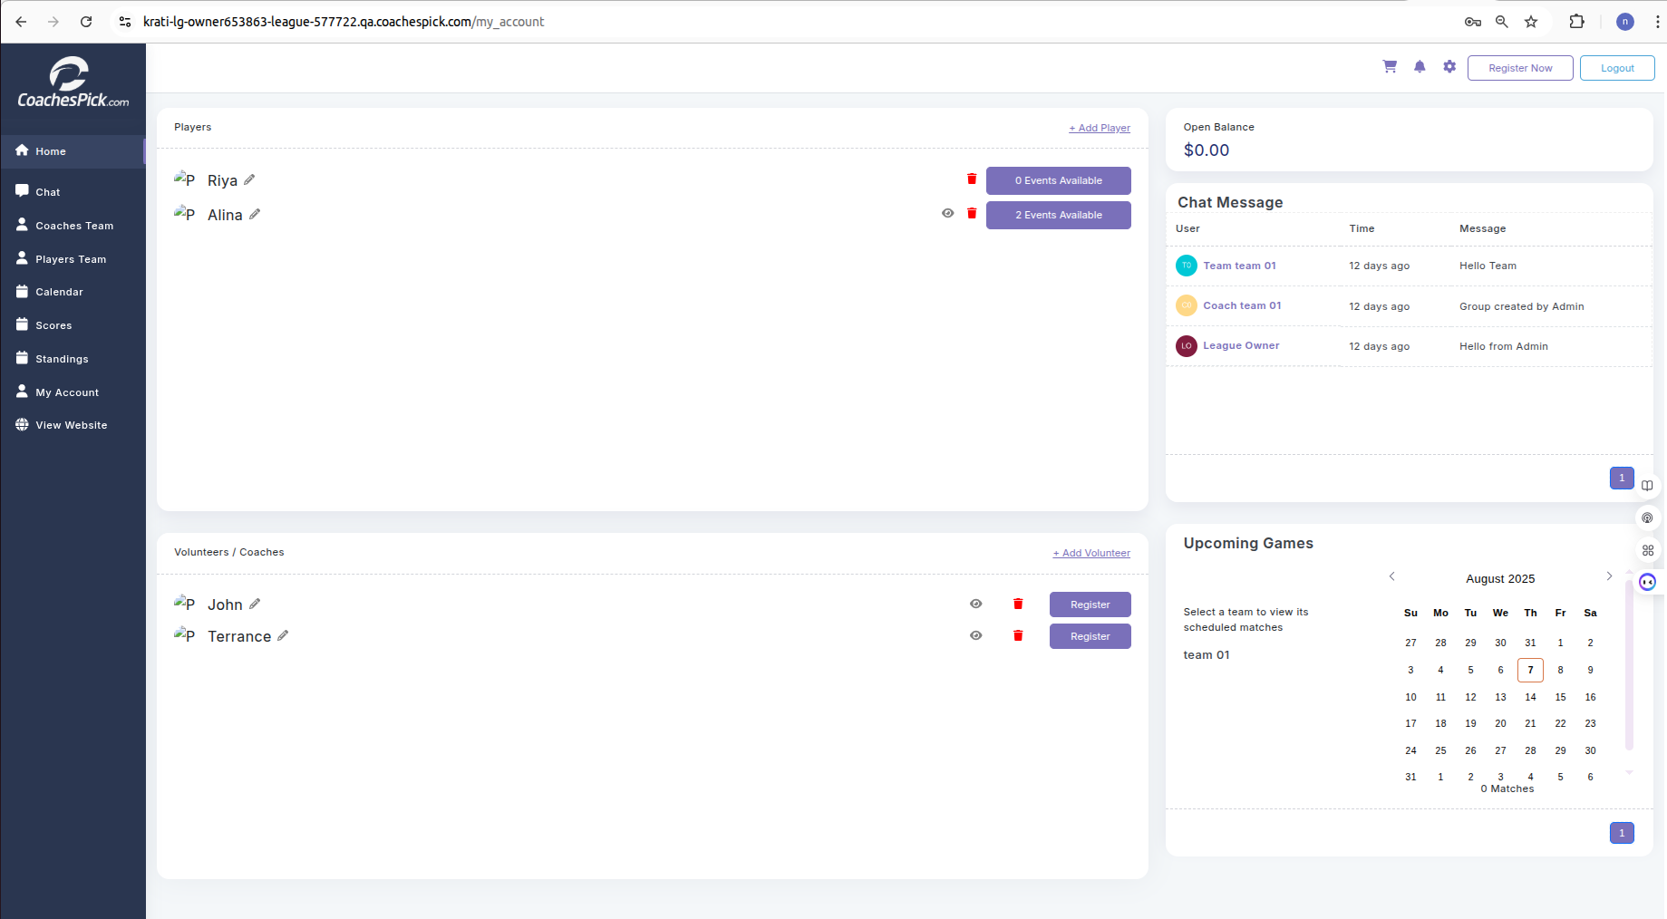

**Overview**

Once logged in, league owners and coaches are directed to a personalized dashboard, which includes:

* Player Management  
   Displayed in a card view, users can see a list of players (e.g., Riya, Alina), the number of events each is available for, and options to edit or delete a player.
* Volunteers / Coaches  
   Similar to player management, this section lists volunteer names (e.g., John, Terrance) and allows for actions like register, edit, or delete.
* Chat Messaging System  
   A chat interface shows real-time group messages from teams, coaches, and league owners.
* Upcoming Games Calendar  
   A calendar widget highlights upcoming games. Users can select a team (e.g., team 01) to view its scheduled matches.
* Account Summary  
   A balance tracker shows any open financial balance (e.g., "$0.00" in the example provided).

**Checkout:**

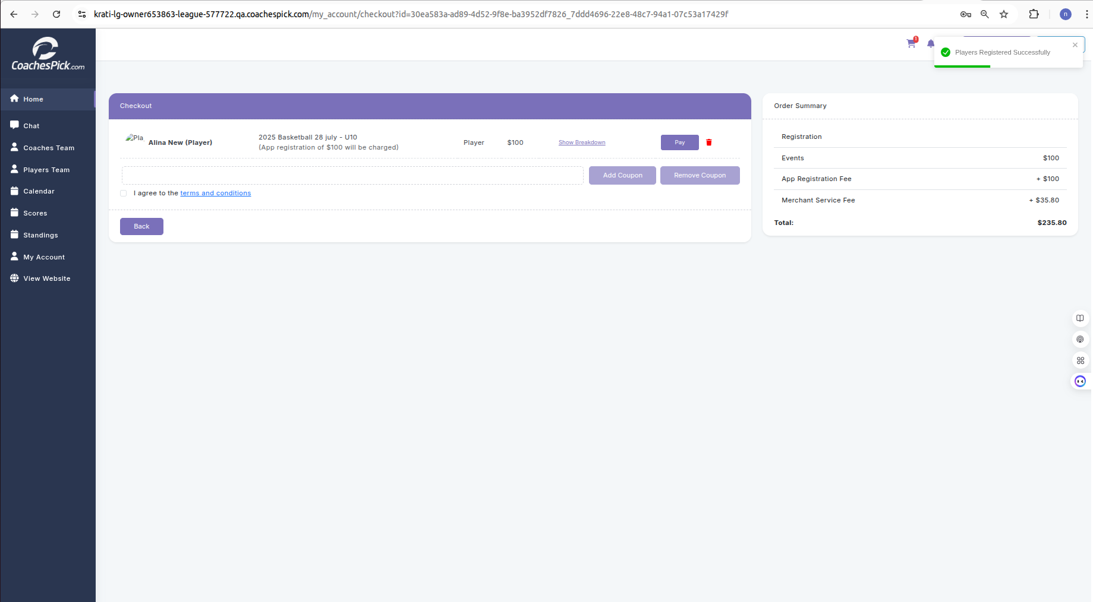

**Overview**

CoachesPick includes a secure checkout and payment interface to handle player registrations for events or leagues. This system ensures transparency and a seamless user experience for league owners and parents.

* Player Registration Summary  
   The checkout screen lists the selected player (e.g., *Alina New*) and the event they are being registered for (e.g., *2025 Basketball 28 July – U10*).
* Pricing Breakdown
* Player Fee is set at the time of creating Event Registration
* App Registration Fee is set at the time of creating League Owner by Admin
* Merchant Service Fee
* Total Amount to be paid
* Functional Buttons
* Add/Remove Coupons – Users can apply discounts if available - which is added at the time of Event Registration.
* Pay – Proceeds to final payment.
* Trash Icon – Removes the player from the checkout list.
* Back Button – Returns to the previous page.
* Terms and Conditions
* Users are required to agree to the platform's terms and conditions before proceeding.
* Real-Time Confirmation
* A success message appears post-payment: "Players Registered Successfully", providing users with feedback on transaction completion.

**League Owner - Account (Business Settings section)**

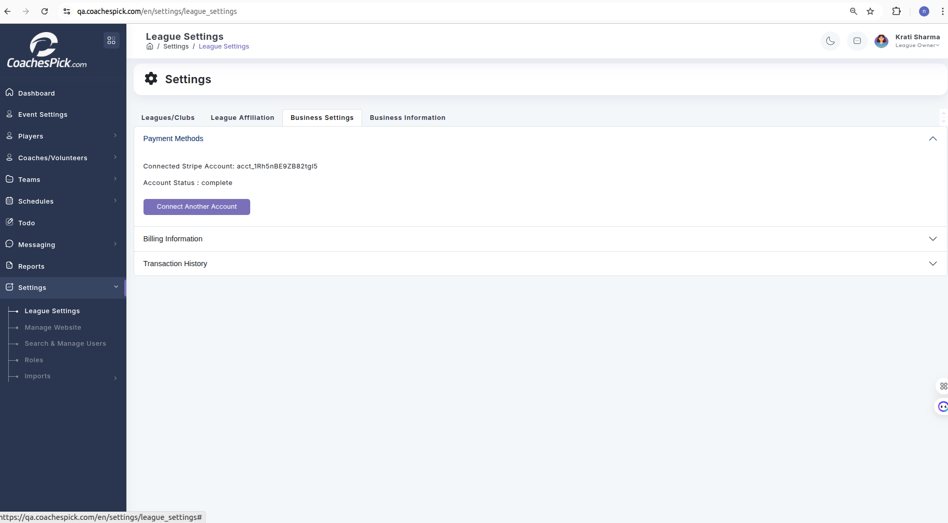

### **Stripe Account Integration for League Owners**

League Owners can connect their Stripe account to receive payments directly through the platform. By clicking the "Connect with Stripe" button, the League Owner is redirected to the Stripe Connect onboarding flow. During this process, they are required to complete a few verification steps to register and activate their Stripe account. Once completed, the League Owner will be able to securely manage and receive payments for their programs, registrations, or events directly through Stripe.